FREE SEMINARS TO TRAIN YOUR BRAIN & RELEASE YOUR AMAZING HIDDEN POTENTIAL!
Discover the proven formula used by Over 70,000 Australians To
Harness Their MIND’s POWER To
Create Success And Happiness
in All Areas Of Life…
Former Trade Commissioner Stopped Smoking After 30 Years
‘As an international consultant and former Trade Commissioner with the Australian Government I have spent 30 years attending literally hundreds of training seminars of every description. The Alpha Dynamic Course delivered more than all the other seminars combined!! The practical techniques I learned are helping me in every area of my life. Now I'm more organised, more relaxed, my memory is better, I stopped smoking (after 30 years of trying), etc. Alpha Training keeps me at my best the whole time rather than 25% of the time, ....you name it - with these practical tools - I can now do it.’
Brendan Dyson – ACT Australia
Doctor Eliminates Nightmares & Sleeping Tablets
‘Since attending your seminar I am much happier, more relaxed and I wake in the morning full of energy now. I have eliminated my nightmares and sleeping tablets, which I have needed for many years. Your seminar has been the best financial investment of my entire life.’
Elizabeth Horvath– MD – Albury, Australia
Achieved 21 High Distinctions, 3 Distinctions and a University Medal.
‘My use of Alpha has helped me immensely in my studies, particularly at University where I achieved 21 High Distinctions, 3 Distinctions and a University Medal.’
Sarah Richardson - Student -
Russell Lea, Australia.
Suffered With Daily Bad Headaches For 5 Years Now Gone‘I suffered from bad headaches every day for 5-6 years, but since I attended the Alpha Training Seminar in 1997 I have not had another headache. It is just fantastic. I also used the Alpha techniques to give myself much needed strength and energy throughout the sickness and loss of my mother. It has really helped me.’
Rita Nilson, Motel Proprietor, Darwin, NT

Now back in MELBOURNE
MAY 5-8 After an 8 year break!
With over 70,000 graduates in Australia alone, Alpha Dynamic is Australia's leading program in mind training that has been established for 28 years in 10 countries. This is THE MOST POWERFUL technique you could decide to learn to create success and happiness in all areas of your life.
In this Mind-opening 2 hour PREVIEW Seminar (suitable for adults and teenagers), you will discover how the Alpha brainwave state can be learned and used to create success in virtually any area you choose. You WILL enjoy!

THIS IS WHAT YOU WILL LEARN ON THE EVENING:
- The basics of Beta , Alpha, Theta and Delta brain wave states and how they impact your performance, feelings and awareness.
- Why it’s important to align the two hemispheres of the brain, and get your brain’s neural network to fire simultaneously.
This is called ‘whole- brain thinking’, it causes you to create amazing results… and it’s far easier to do than you think!
- How to recognize which dominant brain wave state you are in throughout the day, particularly what brain waves states cause your mind to wander, procrastinate and perform poorly.
- What is the super conscious mind and why scientists deem it is so powerful. We all have this hidden capacity!!
- How most people go into powerful Alpha states “accidentally” on a daily basis without realizing it.
- Identify what it feels like to be in the Alpha state.
- How changing your brain state can lead to greatly increased self confidence and self esteem that will stop self sabotaging patterns for good.
- Why your memory and concentration can be unreliable and how to fix it. Everyone has a great memory potential!
- How stress impacts our performance and how you can release stress quickly. 70% of all illness involves stress.
- Why the body heals and recovers up to 10 times faster in the Alpha state. This is the mind / body connection!
- How to recognize and reverse negative and sabotage thinking.
- How the different brainwave states impacts your health, learning and creativity.
- Why confidence and intuition working together creates unprecedented results (A 10 year study of top CEO’s revealed this as a critical success factor).
- How ‘high achievers’ use the alpha state every day without knowing it.
- How the mind and body works together to achieve rapid healing.
- The science behind why prayer, laughter and meditation are so powerful.
- Plus see an amazing demonstration of memory and concentration!
‘Every human being should have the privilege to attend an
Alpha seminar, to help them to derive the best from life
and to contribute to mankind maximally!’
Dr Solomon Guramatunhu- Eye Surgeon- HARARE
‘I was always a believer in the power of the mind after
reading a few books on the subject at university.
After this seminar I realized my incredible ability
on a whole new level!’
Chiraag Chouhan 26yo Manager-


Became A Multi-Millionaire & Used The Skills Gained In The Alpha Seminar
To Do It
‘I attended the Alpha Mind Power Seminar 24 yrs ago after completing university in Melbourne. I set a big goal to become a millionaire within 1 year, having no idea how to do this. Following my intuition & using the confidence & skills gained from your seminar, especially in goal achievement. I joined an Insurance company as a new recruit. Within 3 months I had a staff of 15 agents, within 1 year, 80 agents working for me & achieved my unattainable financial goal twice over! I went on to become a multi- millionaire and used the skills I gained in your seminar to do it. Thank you for the priceless information you imparted. I still use your techniques & have too many successes to mention!’
Taleb Mohammed Businessman
Melbourne/ Harare 2013
5 Major Changes In A Short Period Including New Job & Buying A House In Ascot I Thought I Couldn’t Afford
‘Learning how to use your lower alpha brain frequencies for creating, healing and manifestation are incredible tools for self development and changing outcomes in your life. I was fortunate enough to manifest some rather large changes in mine shortly after doing a seminar when things in my life were pretty much at rock bottom. My boyfriend had left me and I needed to sell my home, and move myself and my two kids closer to the city. I also wanted to get my oldest daughter into a very good school that was hard to get into. I had to get a job, and also buy a new car.
So five major changes were needed and in a specific time frame. I’m absolutely positive that with the help of doing the Alpha techniques that all these things manifested into the positive in a very short amount of time. I sold my house for more than I expected, I bought a house in Ascot that I didn’t expect (I didn’t think I could afford it), my daughter got into her chosen high school, I got a good job and also I got a car that was exactly the weekly repayments that I wanted to pay. Thanks Alpha! I still use you today, I know others too that say that Alpha Mind Power has changed their lives. Susan Welch- Brisbane
PLEASE NOTE
The 2 hr seminar will give you amazing information but we cannot teach the full alpha technique in 2 hours, so decide to learn more if you feel inspired to do so.

Maximised Study Skills & Significant Career Progression Using Alpha
‘I first did the Alpha Dynamic seminar in my early 20’s, during a time when I had dropped out of university to pursue a musical career. The tools that I learnt were instrumental then in changing my life, and I continue to use them today. As an example, part of the seminar focussed on tools to massively improve your memory. Shortly after completing the seminar I returned to university and using these memory techniques my results became straight distinctions and high distinctions. I was studying full time and had a full time job, and still managed excellent results due to the Alpha Dynamic seminar. It is amazing how easy study became after learning how to maximize my study skills.
I continued to use the Alpha Dynamic techniques in every element of my career and personal life. Specific goal setting and visualization exercises were instrumental in my career progression to managing a significant division of a global services company before I turned 30. I also used many other tools learned during the course (too many to mention) to improve my health, sleeping patterns, relationships and other aspects of my life.
In the late 1990’s I had the opportunity to do the Alpha seminar again, and subsequently helped to run a number of seminars for Alpha whilst living and working in Cairns, and then Brisbane. Over this period I personally witnessed literally hundreds of people do the seminar and transform their lives, often overcoming long-term and serious challenges. I can confidently recommend this seminar to anyone wanting to learn simple, practical tools and techniques to significantly improve their life.’
Richard Triggs, Business Owner -Brisbane.
‘The course could have been called ‘Power of the Mind’. Our whole family went to the course and found this to be very beneficial as the techniques learned could be discussed and reinforced. The techniques are many and varied and can be used in all life situations. Our 13y.o. daughter has finally stopped chewing her nails which has been a chronic habit for years. Our other children have improved their focus in school and sport. The memory skills are amazing. An excellent personal development course!’
The Krisanski Family – Buderim Australia

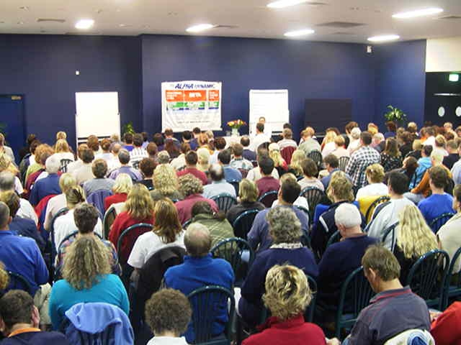
- Why the ‘alpha state’ is the key to unlock the door to your full potential and unlimited mind power.
- How the Alpha Technique is used by thousands of people to set and achieve big goals faster– for example, a Brisbane woman used it to buy a beautiful house in Ascot when she thought there was no way she could afford it.
- How the use of Alpha can be used for prosperity, like a Melbourne University graduate who used it to become a multi-millionaire in one year.
- Why using Alpha can double your memory in 30 days, and find out the rapid learning and study techniques that won a NSW student 21 High Distinctions and a University Medal!
- How Alpha enables you to access your higher creativity and intuition.
- How the power of Alpha can end addictions for good- a former Aussie Trade Commissioner used it to stop smoking after 30 years.
- Why you can end procrastination for good and tap into unlimited energy and motivation during Alpha states.
- Hear about the technique used by an Albury Doctor used to eliminate nightmares and sleeping tablets, and learn to stop fix insomnia and poor sleeping patterns for good.
- Use Alpha to control physical pain & even reverse strokes
About Alpha Dynamic  Alpha Dynamic is now one of Australia's leaders in mind training, personal empowerment and high performance training. With over 70,000 graduates Australia wide, and years of tested, proven results and experience, we can confidently promise a life changing experience, yet still deliver well beyond expectations.  Where Has The Alpha Training Seminar Been Presented in 28 yrs?  Alpha Training has been presented in every capital city of Australia and over 30 regional centres, as well as Dubai, Abu Dhabi, Singapore, Jakarta, Bali, London, New Zealand, South Africa, Zimbabwe, Namibia and Turkey.  How Does Alpha Training Work?  You have wonderful powers of intuition, creativity and imagination. Occasionally you exhibit a great memory, superior concentration and can learn easily. Some days your energy and enthusiasm is well above the usual. But it only happens occasionally! Alpha training teaches you how to relax, focus and access your most powerful mental states whenever you want to. You will learn how to consistently perform at a higher level, moving towards peak performance, systematically rather than occasionally and by accident with no way to repeat the experience. Alpha training gives you extra-ordinary life success techniques to allow you to make the rest to your life, the best of your life. | Who Should Attend a Free Lecture?  - Students wanting to excel and improve memory study skills and concentration  - Anyone who is stressed, negative or feeling down who wants to access high levels of self- confidence and happiness and move forward.  - Sports people who want to dramatically improve their performance without extra effort.  - Business people who want to quickly and successfully expand and grow their business.  - Employees who want to enhance their careers.  - Anyone who wants to eliminate physical or emotional pain for good or just to boost energy.  - Leaders who want to achieve peak performance, better decision-making and focus.  - Anyone who wants to stop smoking or lose weight.  - Happy successful people committed to the joy of living, who want more out of life.  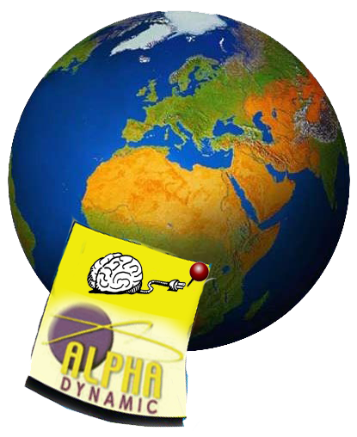
‘I really understood the value of this seminar. I know I will use these teachings
to achieve ALL I want. This seminar was ‘electrifying’
I would suggest all non believers take a chance & allow themselves to be proven wrong!’
Rishi Magecha, 33yo Business Owner –
Your seminar touches the mind, the heart and the soul-it’s the whole package!!
Margie Palmer, 55yo- Bookkeeper

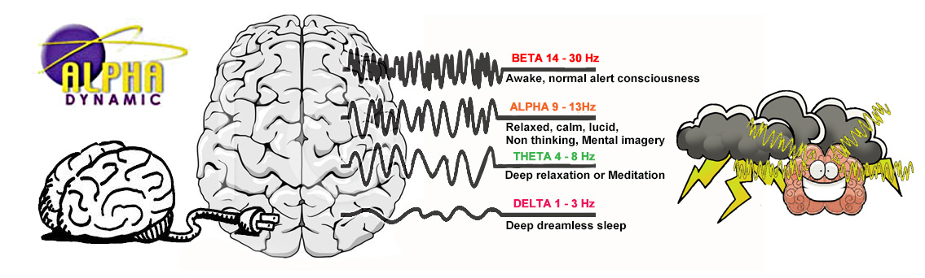
About Your Alpha Brain Level
Of the four levels our brain functions in, Alpha in the most powerful. Theta and Delta are our sleep levels at night, and Beta is our everyday thinking level where we experience stress, negative thinking, poor memory and concentration. Most of us are stuck in the Beta level for 90% of everyday.
Alpha training teaches you how to access and harness the power of your Alpha state
in every area of your life.
Scientists call Alpha our 'super-conscious' level of the brain. It is the level of creativity, intuition and inspiration. Our body can heal up to 10 times faster at 'Alpha'. We access Alpha at night while we can dream & during the day occasionally during peak performance experiences, or when we are very relaxed or engrossed in a task. Children spend the first 5 years of their life in Alpha. By learning to operate in Alpha at will, many remarkable abilities
(e.g. 'super learning', faster healing, pain control) open up .
Times Your brain can ‘slip Into The Alpha State’…….. Naturally:
- When you are experiencing heightened creativity and intuition & achieve amazing outcomes.  - When you are at peak performance during sports or at work & feel like you are ‘in the zone’.  - When you read a book and get lost in the story, and remember the details of what you read long after.  - When you sing, paint, play music, cook, garden or write and find that you have ‘lost track of time’.  ‘This seminar has opened my mind to a new exciting frontier ‘  Lex Lovemore 26yo  ‘A mind-blowing experience, & how to awaken my inner spirit! Exhilerating! ‘  Adrienne Banks, 54yo- Principal / Teacher  ‘I originally came to the seminar to improve my studying and goal achievement, but left with a superior understanding of Alpha brainwaves & all their uses! ‘  Ciaran Coghlan 15yo Student- | - When you are laughing , having fun & feel real JOY.  - When you are dreaming whilst sleeping at night or having a ‘cat nap’ or daydream during the day.  - In times of emergency when you respond with quick thinking, often surprising yourself.  - When you are very relaxed, yet your mind is sharp & alert, ideas are flowing & you feel inspired, like in the shower or on the toilet or at rest

THIS IS YOUR CHANCE TO TAKE A STEP TOWARDS A RICHER, FULLER LIFE. YOU ALREADY POSSESS THE ABILITY AND NOW YOU CAN LEARN HOW TO UNLOCK THIS HIDDEN POTENTIAL.YOU WILL BE SO GLAD YOU DID !
YoUR CHANCE TO ATTEND in Melbourne  Tues. APRIL 4th OR Wed. APRIL 5th  7pm - 9pm  Clarion Hotel on Canterbury  326 Canterbury Rd Forest Hill 4111  ALPHA SEMINAR INTENSIVE  MAY 5th to 8th 2017  ClarionHotel on Canterbury  Fri. 6pm-11pm & Sat 8am-6.30pm,  Sun 8am-10pm & Mon 6pm-10pm  ‘Thank you for this valued seminar!  Powerful, invigorating! I am super excited  to get such an aid and reach the potential within! ‘  Vicky Bowen 50yo- Business woman  ‘Thoroughly enjoyed your seminar. Feeling very inspired, confident and ready to face any situation with the best possible answer. Also learned that love is very important in life. ‘  Kalpana Vyas, 52yo- Travel Agent  NON RELIGIOUS , NON PHILOSOPHICAL, BASED ON SCIENTIFIC RESEARCH THAT IS PROVEN TO WORK over 25 years on thousands of participants!! | 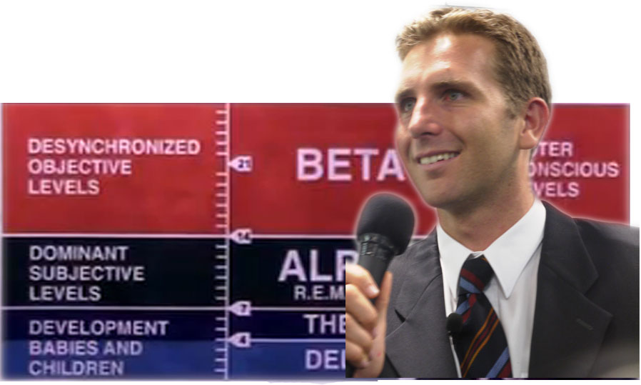  International Speaker:  Peter Heibloem will introduce to you the fundamentals of Alpha Training  and the power of your Mind, firstly at the  2 hour Introductory Seminar.  Later Peter will elaborate on how to use  Alpha for Life changing results at our  MIND POWER INTENSIVE  To Reserve Seats :  BOOK ONLINE AT- www.alphadynamic.com.au  Ask for the free E-Book  OR  Call Peter 1800 072 999  OR email Peter at : info@alphadynamic.com.au  * Unfortunately we have limited seats,  so book early to save & avoid missing out!  
Some more comments from our recent seminar
Alpha has brought me back to my fun-loving nature. I went into a bad state of depression& self-destruction, but now I’m “happy-go –lucky” and positive about life!
Moana Vlahakis 28yo- Model
Very inspiring & mind-opening. Thoroughly enjoyed every session. I came to become more focused & organized ,but gained so much more, especially in the area of self-image.
Kiritea Da Silva, 31yo Bookkeeper

